HTML Graphics

📘 Definition
# Source: AI Source: Provided by: [Data Path: Persons Table -> ID Column: 1, Name_En Column: Motasem Essam] -> From: [ChatGPT] on [5/6/2026]
HTML graphics elements are used to draw and display graphics directly in the browser.
They include:
- vector graphics (SVG)
- dynamic drawings (Canvas)

🧠 Main HTML Graphics Elements
# Source: AI Source: Provided by: [Data Path: Persons Table -> ID Column: 1, Name_En Column: Motasem Essam] -> From: [ChatGPT] on [5/6/2026]
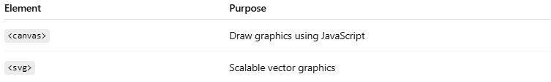
Element | Purpose
<canvas> | Draw graphics using JavaScript
<svg> | Scalable vector graphics

1. 🖌️ <canvas> Element
# Source: AI Source: Provided by: [Data Path: Persons Table -> ID Column: 1, Name_En Column: Motasem Essam] -> From: [ChatGPT] on [5/6/2026]
📖 Description
<canvas> is used to draw graphics via JavaScript:
- shapes
- lines
- animations
- games
💻 Example:
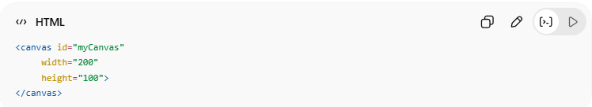
<canvas id="myCanvas"
width="200"
height="100">
</canvas>
👉 Requires JavaScript to draw inside it

🎯 Simple JavaScript Example
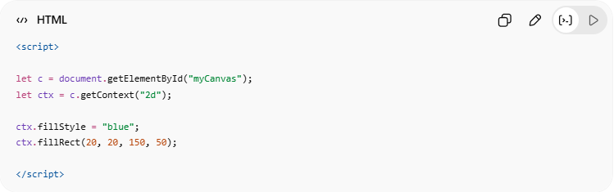
<script>
let c = document.getElementById("myCanvas");
let ctx = c.getContext("2d");
ctx.fillStyle = "blue";
ctx.fillRect(20, 20, 150, 50);
</script>

2. 🧩 <svg> Element
# Source: AI Source: Provided by: [Data Path: Persons Table -> ID Column: 1, Name_En Column: Motasem Essam] -> From: [ChatGPT] on [5/6/2026]
📖 Description
SVG is used for vector graphics:
- sharp at any size
- no quality loss
- XML-based

💻 Example:
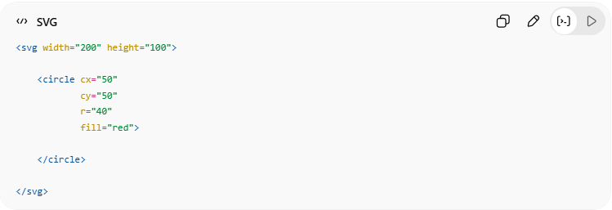
<svg width="200" height="100">

<circle cx="50"
cy="50"
r="40"
fill="red">

</circle>

</svg>
👉 Draws a red circle

⚖️ Differences Between SVG and Canvas
# Source: AI Source: Provided by: [Data Path: Persons Table -> ID Column: 1, Name_En Column: Motasem Essam] -> From: [ChatGPT] on [5/6/2026]
Both SVG and Canvas are used to create graphics in HTML, but they work very differently.
- SVG → vector graphics
- Canvas → bitmap/pixel graphics

🧠 Main Difference
# Source: AI Source: Provided by: [Data Path: Persons Table -> ID Column: 1, Name_En Column: Motasem Essam] -> From: [ChatGPT] on [5/6/2026]
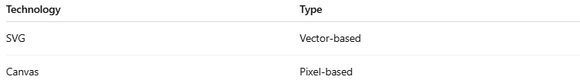
Technology | Type
SVG | Vector-based
Canvas | Pixel-based

📊 SVG vs Canvas Comparison
# Source: AI Source: Provided by: [Data Path: Persons Table -> ID Column: 1, Name_En Column: Motasem Essam] -> From: [ChatGPT] on [5/6/2026]
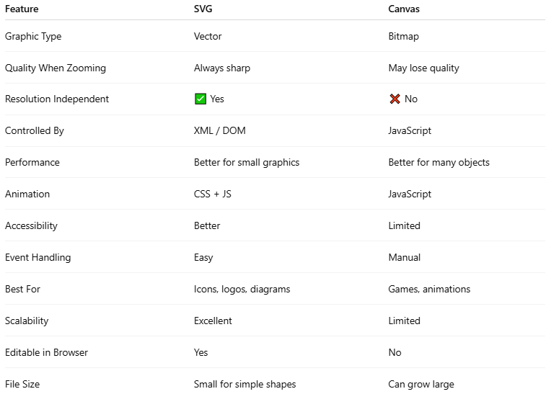
Feature | SVG | Canvas
Graphic Type | Vector | Bitmap
Quality When Zooming | Always sharp | May lose quality
Resolution Independent | ✅ Yes | ❌ No
Controlled By | XML / DOM | JavaScript
Performance | Better for small graphics | Better for many objects
Animation | CSS + JS | JavaScript
Accessibility | Better | Limited
Event Handling | Easy | Manual
Best For | Icons, logos, diagrams | Games, animations
Scalability | Excellent | Limited
Editable in Browser | Yes | No
File Size | Small for simple shapes | Can grow large

🎯 When to Use SVG
# Source: AI Source: Provided by: [Data Path: Persons Table -> ID Column: 1, Name_En Column: Motasem Essam] -> From: [ChatGPT] on [5/6/2026]
✅ Best for:
- logos
- icons
- diagrams
- charts
- UI graphics
✅ Advantages:
- scalable
- accessible
- editable
- CSS styling support

🎮 When to Use Canvas
# Source: AI Source: Provided by: [Data Path: Persons Table -> ID Column: 1, Name_En Column: Motasem Essam] -> From: [ChatGPT] on [5/6/2026]
✅ Best for:
- games
- animations
- image manipulation
- real-time rendering
✅ Advantages:
- faster for many objects
- powerful drawing API
- dynamic rendering

🧪 Visual Comparison
# Source: AI Source: Provided by: [Data Path: Persons Table -> ID Column: 1, Name_En Column: Motasem Essam] -> From: [ChatGPT] on [5/6/2026]
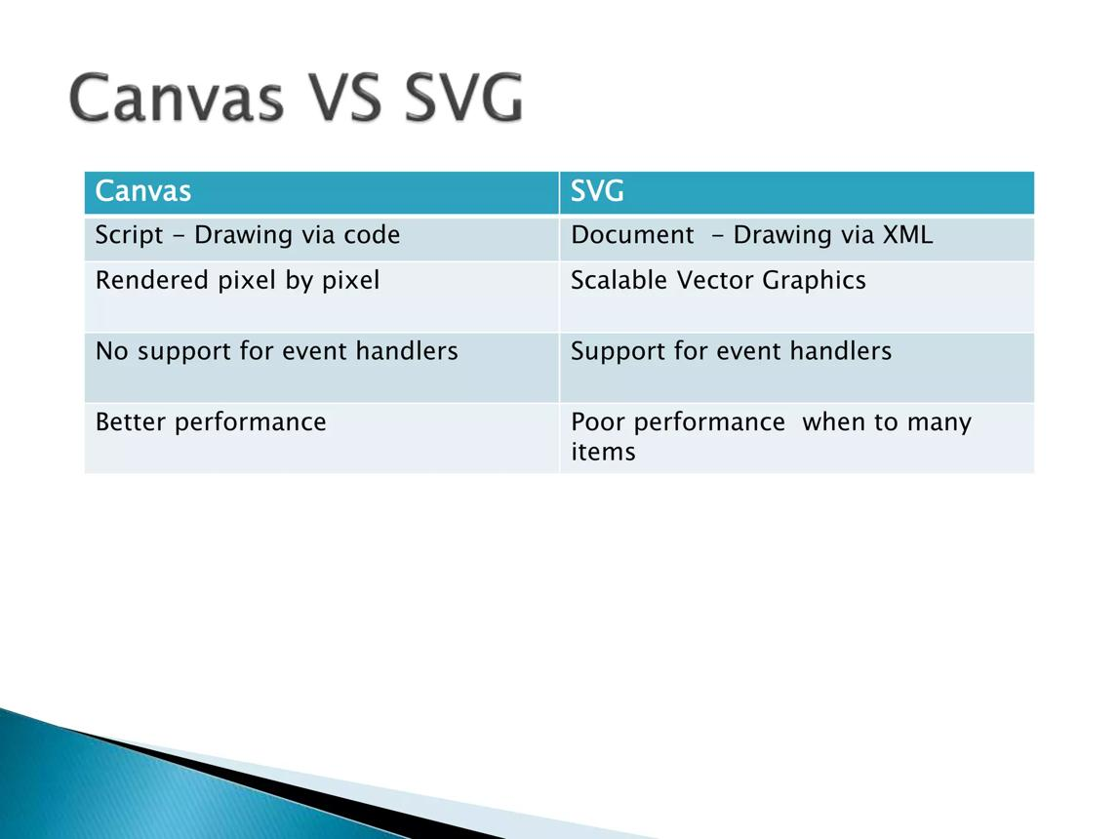
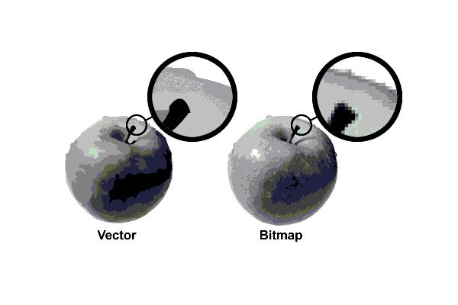
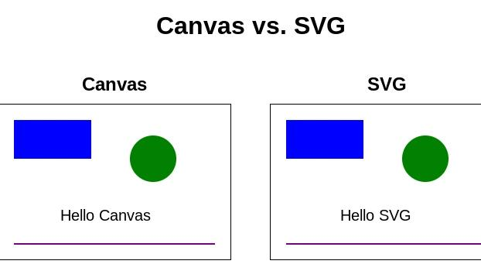
6

⚠️ Important Notes

✅ SVG elements exist in the DOM
# Source: AI Source: Provided by: [Data Path: Persons Table -> ID Column: 1, Name_En Column: Motasem Essam] -> From: [ChatGPT] on [5/6/2026]
👉 Easy interaction and styling

❌ Canvas does NOT keep drawn objects
# Source: AI Source: Provided by: [Data Path: Persons Table -> ID Column: 1, Name_En Column: Motasem Essam] -> From: [ChatGPT] on [5/6/2026]
👉 After drawing, objects become pixels

✅ Canvas performs better for heavy animations
# Source: AI Source: Provided by: [Data Path: Persons Table -> ID Column: 1, Name_En Column: Motasem Essam] -> From: [ChatGPT] on [5/6/2026]
👉 Especially games

✅ SVG scales perfectly on all screens
# Source: AI Source: Provided by: [Data Path: Persons Table -> ID Column: 1, Name_En Column: Motasem Essam] -> From: [ChatGPT] on [5/6/2026]
👉 Great for responsive design

🚀 In short:
# Source: AI Source: Provided by: [Data Path: Persons Table -> ID Column: 1, Name_En Column: Motasem Essam] -> From: [ChatGPT] on [5/6/2026]
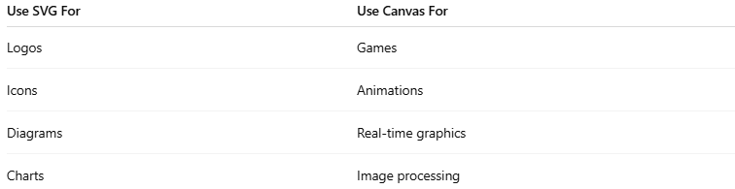
Use SVG For | Use Canvas For
Logos | Games
Icons | Animations
Diagrams | Real-time graphics
Charts | Image processing

🎯 Simple Rule
# Source: AI Source: Provided by: [Data Path: Persons Table -> ID Column: 1, Name_En Column: Motasem Essam] -> From: [ChatGPT] on [5/6/2026]
- 🧩 SVG → scalable vector graphics
- 🖌️ Canvas → dynamic pixel drawing

💻 Example

Full Example
# Source: AI Source: Provided by: [Data Path: Persons Table -> ID Column: 1, Name_En Column: Motasem Essam] -> From: [ChatGPT] on [5/6/2026]
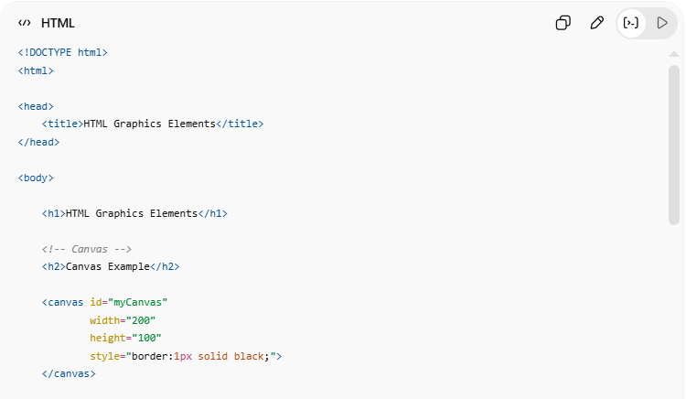
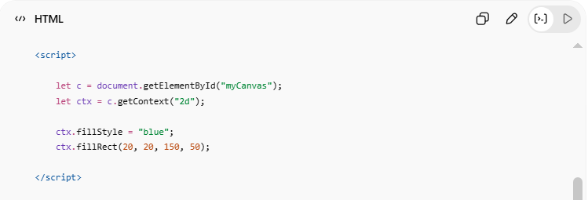
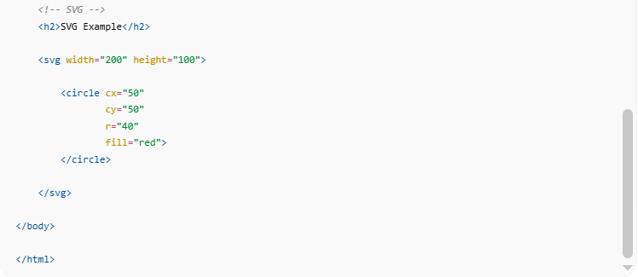
<!DOCTYPE html>
<html>

<head>
<title>HTML Graphics Elements</title>
</head>

<body>

<h1>HTML Graphics Elements</h1>

<!-- Canvas -->
<h2>Canvas Example</h2>

<canvas id="myCanvas"
width="200"
height="100"
style="border:1px solid black;">
</canvas>

<script>

let c = document.getElementById("myCanvas");
let ctx = c.getContext("2d");

ctx.fillStyle = "blue";
ctx.fillRect(20, 20, 150, 50);

</script>

<!-- SVG -->
<h2>SVG Example</h2>

<svg width="200" height="100">

<circle cx="50"
cy="50"
r="40"
fill="red">
</circle>

</svg>

</body>

</html>

Real Example
# Source: ScreenShot Source: Provided by: [Persons Table -> ID Column: 1, Name_En Column: Motasem Essam] -> Tool: [Automation Table -> ID Column: 16, Name_En Column: Screen Capture] -> From [Operating System: Windows] on [5/6/2026]
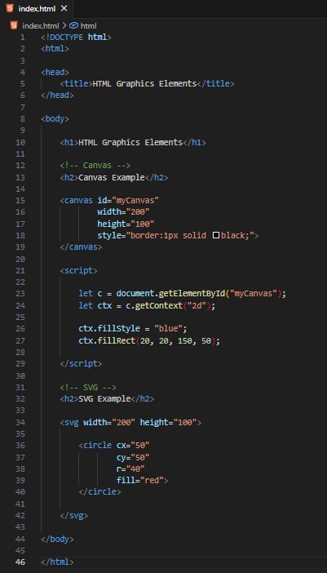
<!DOCTYPE html>
<html>

<head>
<title>HTML Graphics Elements</title>
</head>

<body>

<h1>HTML Graphics Elements</h1>

<!-- Canvas -->
<h2>Canvas Example</h2>

<canvas id="myCanvas"
width="200"
height="100"
style="border:1px solid black;">
</canvas>

<script>

let c = document.getElementById("myCanvas");
let ctx = c.getContext("2d");

ctx.fillStyle = "blue";
ctx.fillRect(20, 20, 150, 50);

</script>

<!-- SVG -->
<h2>SVG Example</h2>

<svg width="200" height="100">

<circle cx="50"
cy="50"
r="40"
fill="red">
</circle>

</svg>

</body>

</html>
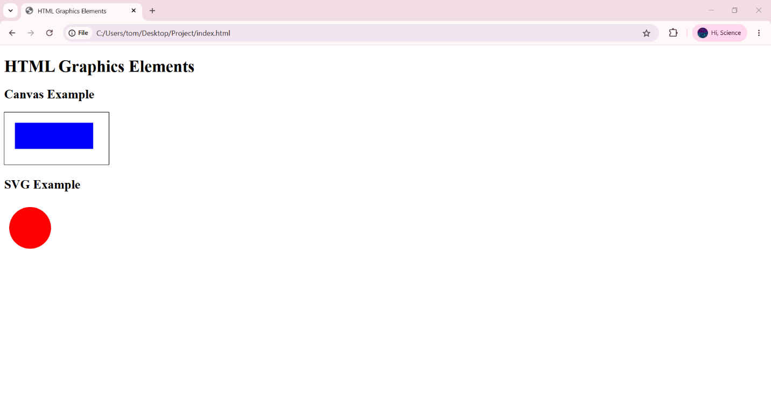

🧪 What You Can Test
# Source: AI Source: Provided by: [Data Path: Persons Table -> ID Column: 1, Name_En Column: Motasem Essam] -> From: [ChatGPT] on [5/6/2026]
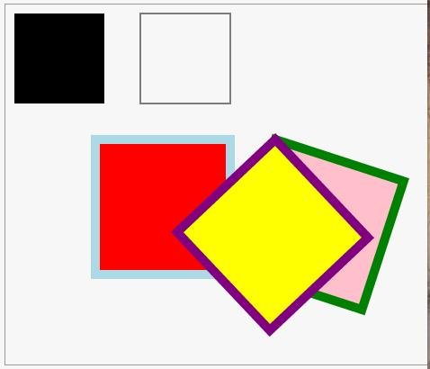
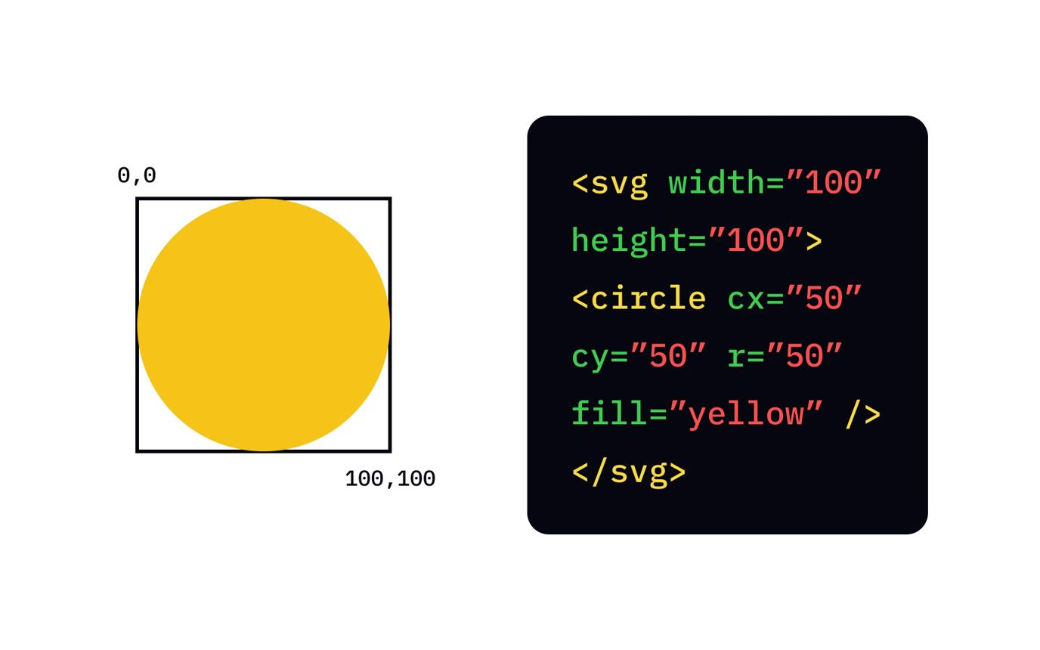


🖌️ HTML Canvas Graphics

📘 Definition
# Source: AI Source: Provided by: [Data Path: Persons Table -> ID Column: 1, Name_En Column: Motasem Essam] -> From: [ChatGPT] on [5/6/2026]
The HTML <canvas> element is used to draw graphics with JavaScript.
Canvas can create:
- lines
- circles
- text
- gradients
- images
- animations

🧠 Main Canvas Methods
# Source: AI Source: Provided by: [Data Path: Persons Table -> ID Column: 1, Name_En Column: Motasem Essam] -> From: [ChatGPT] on [5/6/2026]
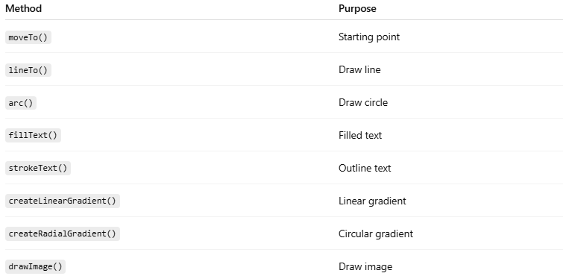
Method | Purpose
moveTo() | Starting point
lineTo() | Draw line
arc() | Draw circle
fillText() | Filled text
strokeText() | Outline text
createLinearGradient() | Linear gradient
createRadialGradient() | Circular gradient
drawImage() | Draw image

1. 📏 Draw a Line
# Source: AI Source: Provided by: [Data Path: Persons Table -> ID Column: 1, Name_En Column: Motasem Essam] -> From: [ChatGPT] on [5/6/2026]
📖 Description
Draws a straight line.
💻 Example:
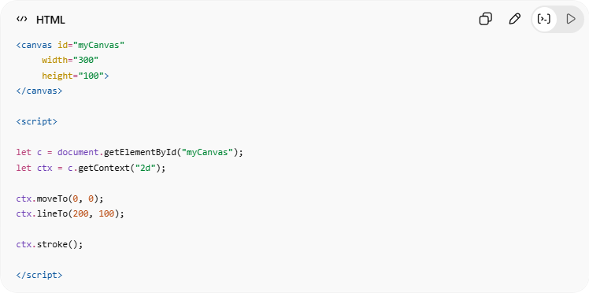
<canvas id="myCanvas"
width="300"
height="100">
</canvas>
<script>
let c = document.getElementById("myCanvas");
let ctx = c.getContext("2d");
ctx.moveTo(0, 0);
ctx.lineTo(200, 100);
ctx.stroke();
</script>

2. 🔵 Draw a Circle
# Source: AI Source: Provided by: [Data Path: Persons Table -> ID Column: 1, Name_En Column: Motasem Essam] -> From: [ChatGPT] on [5/6/2026]
📖 Description
Draws a circle using arc().
💻 Example:
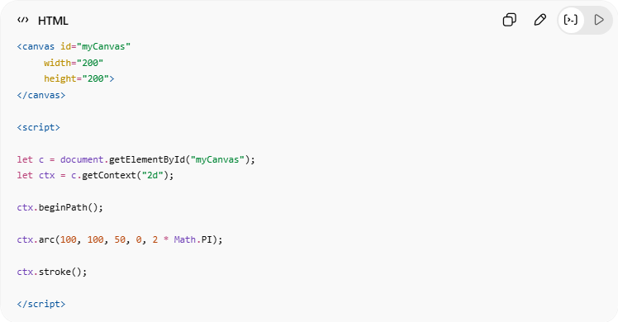
<canvas id="myCanvas"
width="200"
height="200">
</canvas>
<script>
let c = document.getElementById("myCanvas");
let ctx = c.getContext("2d");
ctx.beginPath();
ctx.arc(100, 100, 50, 0, 2 * Math.PI);
ctx.stroke();
</script>

3. 🔤 Draw a Text
# Source: AI Source: Provided by: [Data Path: Persons Table -> ID Column: 1, Name_En Column: Motasem Essam] -> From: [ChatGPT] on [5/6/2026]
📖 Description
Displays filled text.
💻 Example:
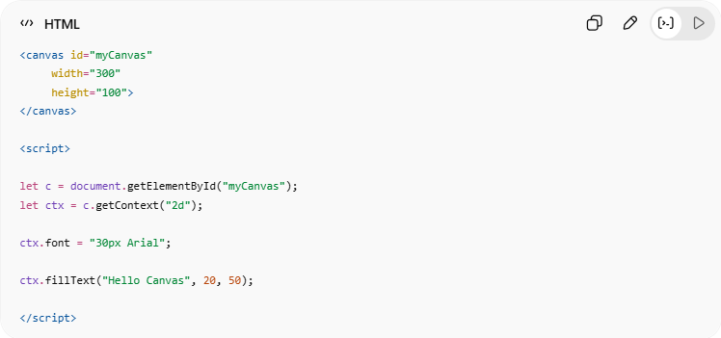
<canvas id="myCanvas"
width="300"
height="100">
</canvas>
<script>
let c = document.getElementById("myCanvas");
let ctx = c.getContext("2d");
ctx.font = "30px Arial";
ctx.fillText("Hello Canvas", 20, 50);
</script>

4. ✏️ Stroke Text
# Source: AI Source: Provided by: [Data Path: Persons Table -> ID Column: 1, Name_En Column: Motasem Essam] -> From: [ChatGPT] on [5/6/2026]
📖 Description
Creates outlined text.
💻 Example:
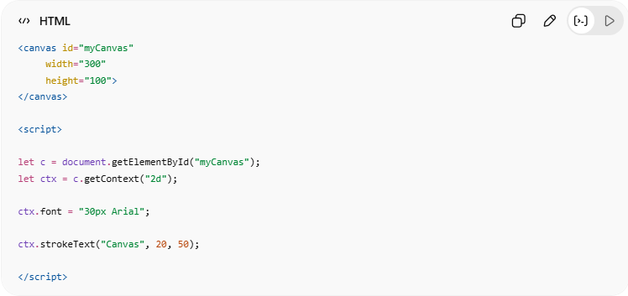
<canvas id="myCanvas"
width="300"
height="100">
</canvas>
<script>
let c = document.getElementById("myCanvas");
let ctx = c.getContext("2d");
ctx.font = "30px Arial";
ctx.strokeText("Canvas", 20, 50);
</script>

5. 🌈 Draw Linear Gradient
# Source: AI Source: Provided by: [Data Path: Persons Table -> ID Column: 1, Name_En Column: Motasem Essam] -> From: [ChatGPT] on [5/6/2026]
📖 Description
Creates a color transition in a straight line.
💻 Example:
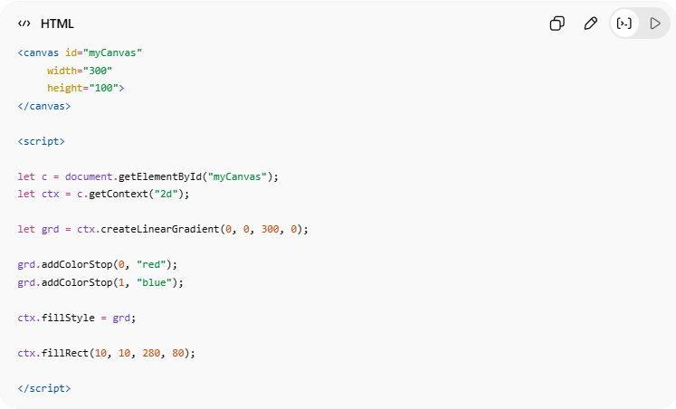
<canvas id="myCanvas"
width="300"
height="100">
</canvas>
<script>
let c = document.getElementById("myCanvas");
let ctx = c.getContext("2d");
let grd = ctx.createLinearGradient(0, 0, 300, 0);
grd.addColorStop(0, "red");
grd.addColorStop(1, "blue");
ctx.fillStyle = grd;
ctx.fillRect(10, 10, 280, 80);
</script>

6. 🟣 Draw Circular Gradient
# Source: AI Source: Provided by: [Data Path: Persons Table -> ID Column: 1, Name_En Column: Motasem Essam] -> From: [ChatGPT] on [5/6/2026]
📖 Description
Creates a radial/circular gradient.
💻 Example:
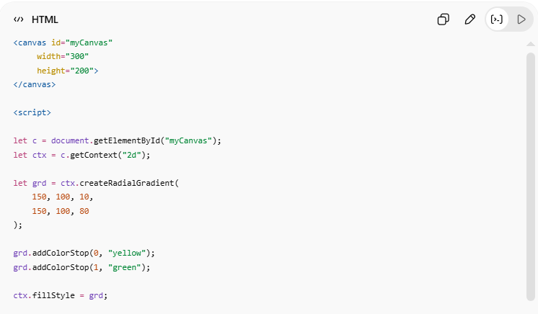
<canvas id="myCanvas"
width="300"
height="200">
</canvas>
<script>
let c = document.getElementById("myCanvas");
let ctx = c.getContext("2d");
let grd = ctx.createRadialGradient(
150, 100, 10,
150, 100, 80
);
grd.addColorStop(0, "yellow");
grd.addColorStop(1, "green");
ctx.fillStyle = grd;
ctx.fillRect(0, 0, 300, 200);
</script>

7. 🖼️ Draw Image
# Source: AI Source: Provided by: [Data Path: Persons Table -> ID Column: 1, Name_En Column: Motasem Essam] -> From: [ChatGPT] on [5/6/2026]
📖 Description
Draws an image inside canvas.
💻 Example:
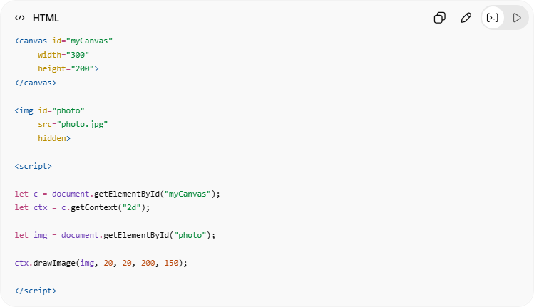
<canvas id="myCanvas"
width="300"
height="200">
</canvas>
<img id="photo"
src="photo.jpg"
hidden>
<script>
let c = document.getElementById("myCanvas");
let ctx = c.getContext("2d");
let img = document.getElementById("photo");
ctx.drawImage(img, 20, 20, 200, 150);
</script>

💻 Example

Full Example
# Source: AI Source: Provided by: [Data Path: Persons Table -> ID Column: 1, Name_En Column: Motasem Essam] -> From: [ChatGPT] on [5/6/2026]
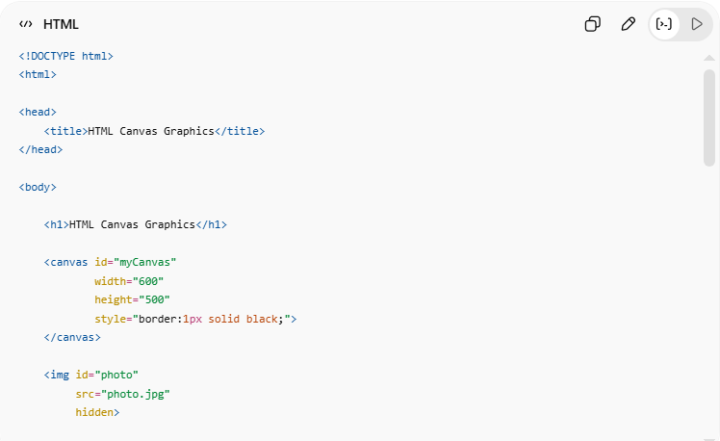
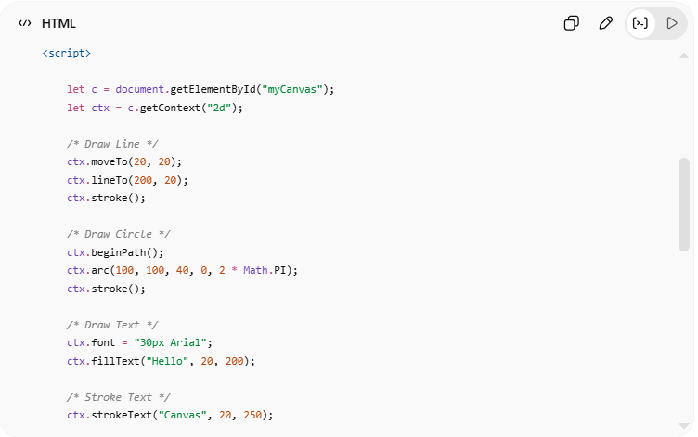
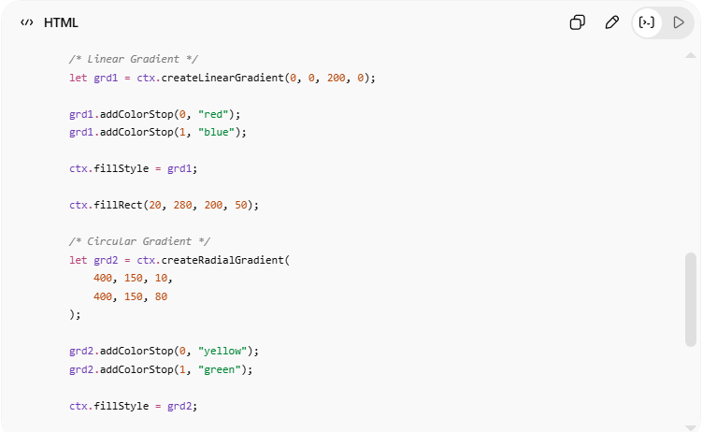
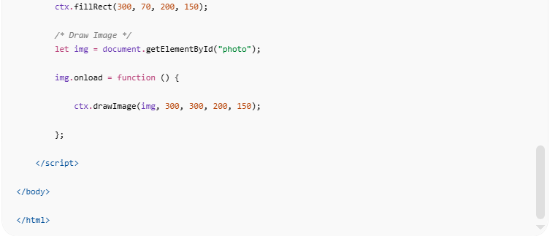
<!DOCTYPE html>
<html>
<head>
<title>HTML Canvas Graphics</title>
</head>
<body>
<h1>HTML Canvas Graphics</h1>
<canvas id="myCanvas"
width="600"
height="500"
style="border:1px solid black;">
</canvas>
<img id="photo"
src="photo.jpg"
hidden>
<script>
let c = document.getElementById("myCanvas");
let ctx = c.getContext("2d");
/* Draw Line */
ctx.moveTo(20, 20);
ctx.lineTo(200, 20);
ctx.stroke();
/* Draw Circle */
ctx.beginPath();
ctx.arc(100, 100, 40, 0, 2 * Math.PI);
ctx.stroke();
/* Draw Text */
ctx.font = "30px Arial";
ctx.fillText("Hello", 20, 200);
/* Stroke Text */
ctx.strokeText("Canvas", 20, 250);
/* Linear Gradient */
let grd1 = ctx.createLinearGradient(0, 0, 200, 0);
grd1.addColorStop(0, "red");
grd1.addColorStop(1, "blue");
ctx.fillStyle = grd1;
ctx.fillRect(20, 280, 200, 50);
/* Circular Gradient */
let grd2 = ctx.createRadialGradient(
400, 150, 10,
400, 150, 80
);
grd2.addColorStop(0, "yellow");
grd2.addColorStop(1, "green");
ctx.fillStyle = grd2;
ctx.fillRect(300, 70, 200, 150);
/* Draw Image */
let img = document.getElementById("photo");
img.onload = function () {
ctx.drawImage(img, 300, 300, 200, 150);
};
</script>
</body>
</html>

Real Example
# Source: ScreenShot Source: Provided by: [Persons Table -> ID Column: 1, Name_En Column: Motasem Essam] -> Tool: [Automation Table -> ID Column: 16, Name_En Column: Screen Capture] -> From [Operating System: Windows] on [5/6/2026]
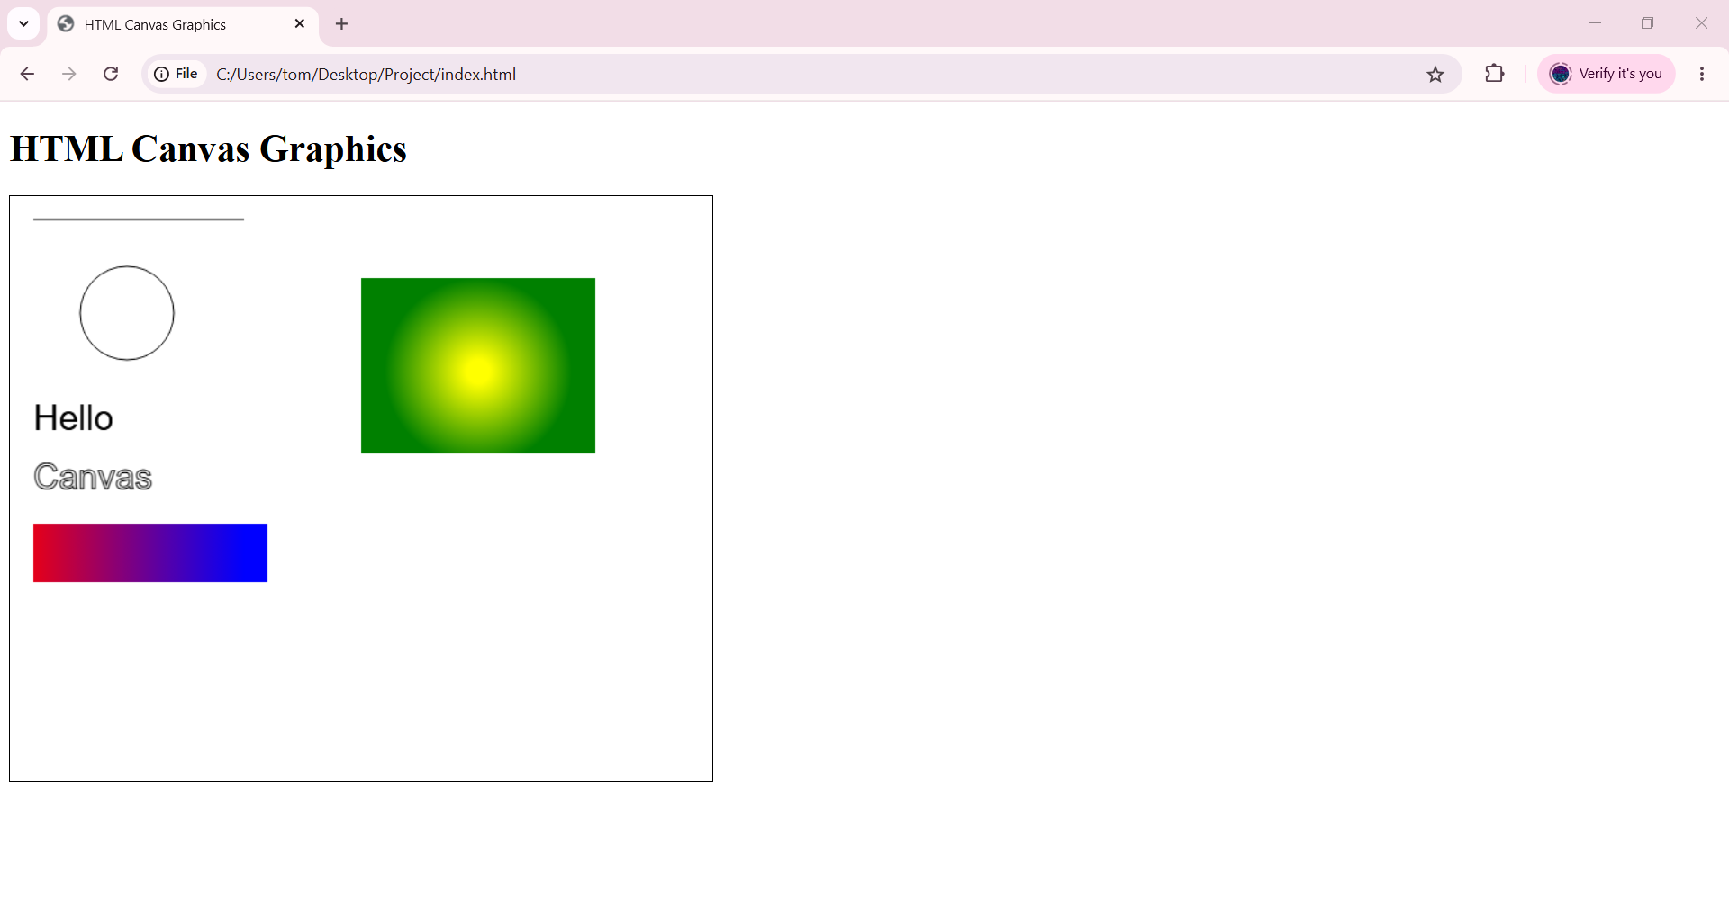

🧪 What You Can Test
# Source: AI Source: Provided by: [Data Path: Persons Table -> ID Column: 1, Name_En Column: Motasem Essam] -> From: [ChatGPT] on [5/6/2026]
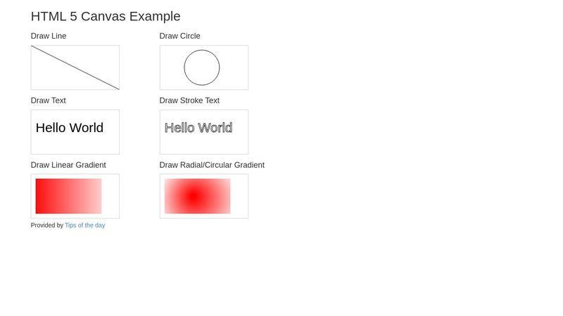
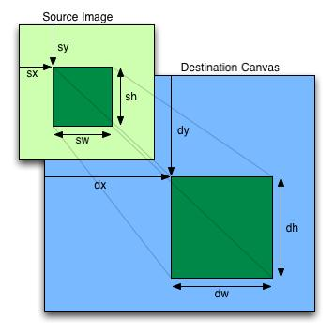
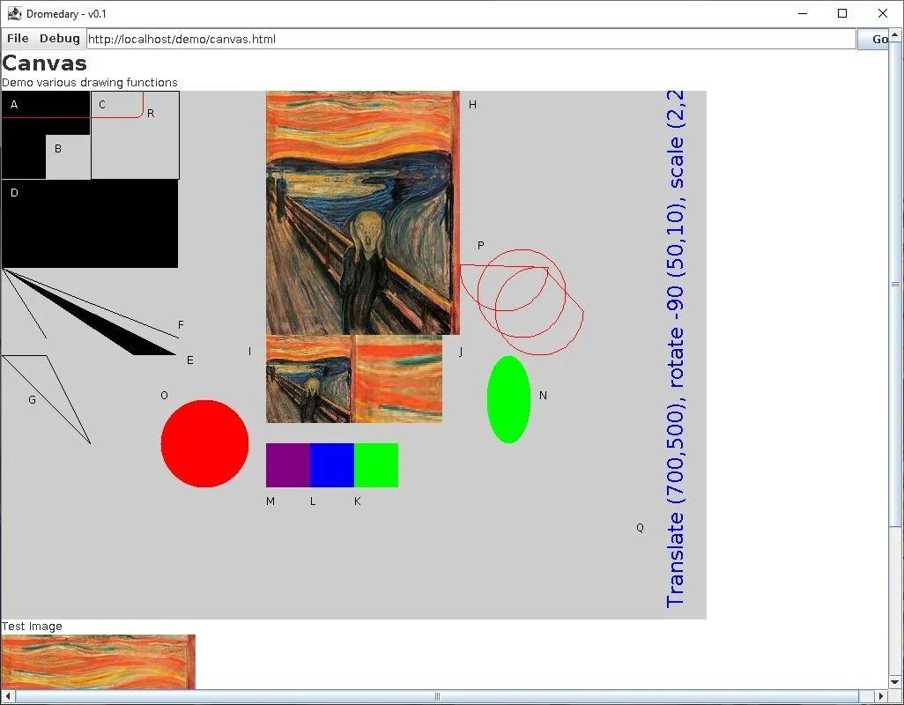
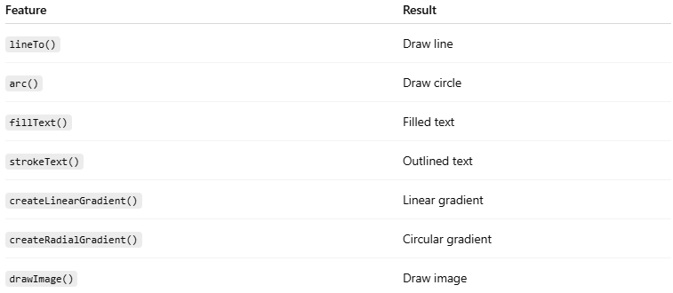
Feature | Result
lineTo() | Draw line
arc() | Draw circle
fillText() | Filled text
strokeText() | Outlined text
createLinearGradient() | Linear gradient
createRadialGradient() | Circular gradient
drawImage() | Draw image

⚠️ Important Notes

✅ Canvas requires JavaScript
# Source: AI Source: Provided by: [Data Path: Persons Table -> ID Column: 1, Name_En Column: Motasem Essam] -> From: [ChatGPT] on [5/6/2026]
👉 Canvas alone cannot draw graphics

✅ Use beginPath() for new shapes
# Source: AI Source: Provided by: [Data Path: Persons Table -> ID Column: 1, Name_En Column: Motasem Essam] -> From: [ChatGPT] on [5/6/2026]
👉 Prevents shape connection issues

✅ Images must load before drawing
# Source: AI Source: Provided by: [Data Path: Persons Table -> ID Column: 1, Name_En Column: Motasem Essam] -> From: [ChatGPT] on [5/6/2026]
👉 Use onload

❌ Canvas graphics are bitmap-based
# Source: AI Source: Provided by: [Data Path: Persons Table -> ID Column: 1, Name_En Column: Motasem Essam] -> From: [ChatGPT] on [5/6/2026]
👉 Scaling may reduce quality

🚀 In short:
# Source: AI Source: Provided by: [Data Path: Persons Table -> ID Column: 1, Name_En Column: Motasem Essam] -> From: [ChatGPT] on [5/6/2026]
HTML Canvas uses JavaScript drawing methods to create lines, circles, text, gradients, and images dynamically inside webpages.

🧩 HTML SVG Graphics

📘 Definition
# Source: AI Source: Provided by: [Data Path: Persons Table -> ID Column: 1, Name_En Column: Motasem Essam] -> From: [ChatGPT] on [5/6/2026]
SVG (Scalable Vector Graphics) is used to create vector-based graphics in HTML.
SVG graphics:
- stay sharp at any size
- are XML-based
- can be styled with CSS
- can be controlled with JavaScript

🧠 Common SVG Elements
# Source: AI Source: Provided by: [Data Path: Persons Table -> ID Column: 1, Name_En Column: Motasem Essam] -> From: [ChatGPT] on [5/6/2026]
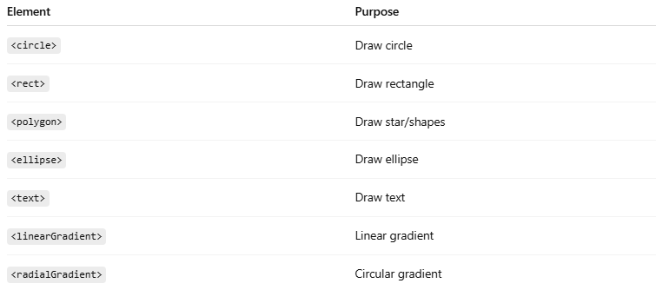
Element | Purpose
<circle> | Draw circle
<rect> | Draw rectangle
<polygon> | Draw star/shapes
<ellipse> | Draw ellipse
<text> | Draw text
<linearGradient> | Linear gradient
<radialGradient> | Circular gradient

1. 🔵 SVG Circle
# Source: AI Source: Provided by: [Data Path: Persons Table -> ID Column: 1, Name_En Column: Motasem Essam] -> From: [ChatGPT] on [5/6/2026]
📖 Description
Draws a circle.
💻 Example:
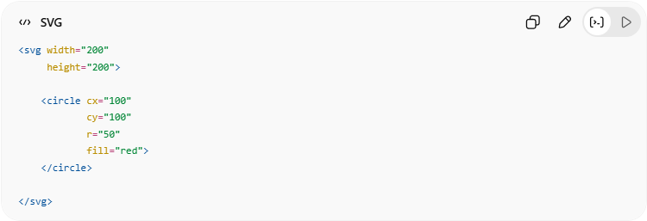
<svg width="200"
height="200">

<circle cx="100"
cy="100"
r="50"
fill="red">
</circle>

</svg>

2. 🟥 SVG Rectangle
# Source: AI Source: Provided by: [Data Path: Persons Table -> ID Column: 1, Name_En Column: Motasem Essam] -> From: [ChatGPT] on [5/6/2026]
📖 Description
Draws a rectangle.
💻 Example:
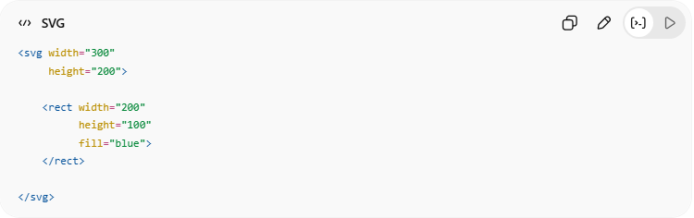
<svg width="300"
height="200">

<rect width="200"
height="100"
fill="blue">
</rect>

</svg>

3. 🟪 SVG Rectangle with Opacity and Rounded Corners
# Source: AI Source: Provided by: [Data Path: Persons Table -> ID Column: 1, Name_En Column: Motasem Essam] -> From: [ChatGPT] on [5/6/2026]
📖 Description
Adds:
- rounded corners
- transparency
💻 Example:
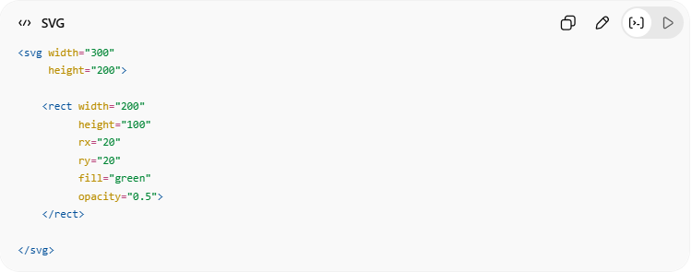
<svg width="300"
height="200">

<rect width="200"
height="100"
rx="20"
ry="20"
fill="green"
opacity="0.5">
</rect>

</svg>

4. ⭐ SVG Star
# Source: AI Source: Provided by: [Data Path: Persons Table -> ID Column: 1, Name_En Column: Motasem Essam] -> From: [ChatGPT] on [5/6/2026]
📖 Description
Uses <polygon> to create a star shape.
💻 Example:
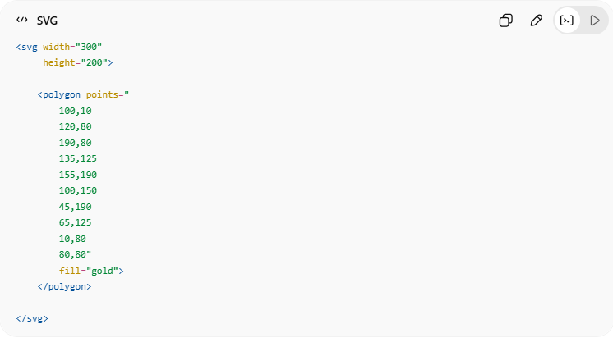
<svg width="300"
height="200">

<polygon points="
100,10
120,80
190,80
135,125
155,190
100,150
45,190
65,125
10,80
80,80"
fill="gold">
</polygon>

</svg>

5. 🌈 SVG Gradient Ellipse and Text
# Source: AI Source: Provided by: [Data Path: Persons Table -> ID Column: 1, Name_En Column: Motasem Essam] -> From: [ChatGPT] on [5/6/2026]
📖 Description
Creates:
- gradient ellipse
- SVG text
💻 Example:
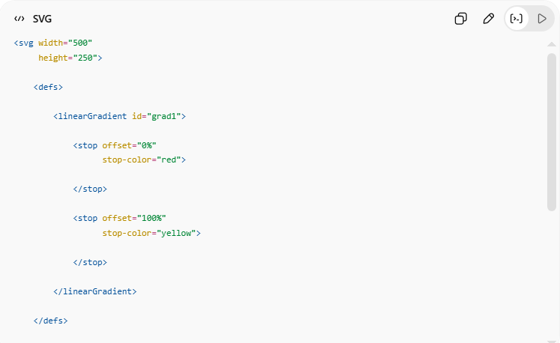
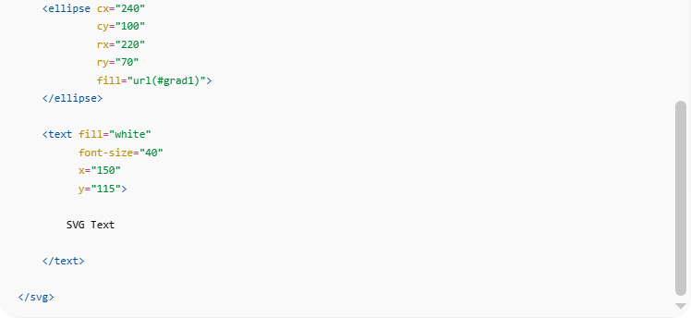
<svg width="500"
height="250">

<defs>

<linearGradient id="grad1">

<stop offset="0%"
stop-color="red">

</stop>

<stop offset="100%"
stop-color="yellow">

</stop>

</linearGradient>

</defs>

<ellipse cx="240"
cy="100"
rx="220"
ry="70"
fill="url(#grad1)">
</ellipse>

<text fill="white"
font-size="40"
x="150"
y="115">

SVG Text

</text>

</svg>

💻 Example

Full Example
# Source: AI Source: Provided by: [Data Path: Persons Table -> ID Column: 1, Name_En Column: Motasem Essam] -> From: [ChatGPT] on [5/6/2026]
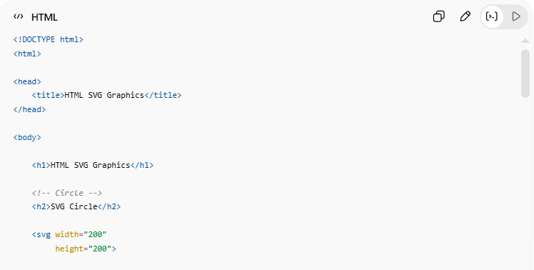
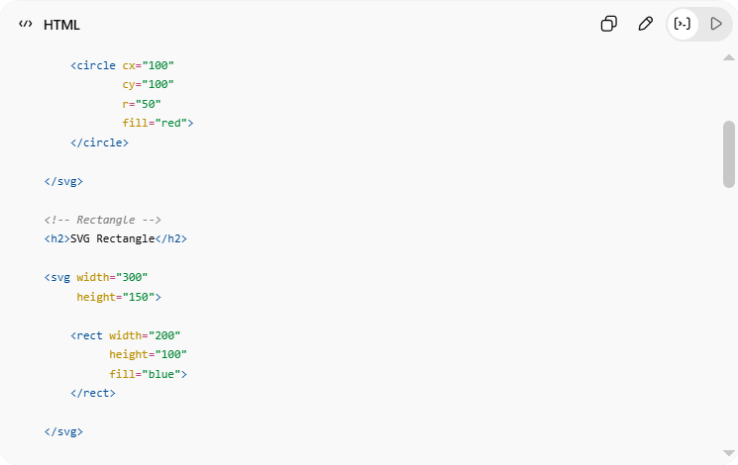
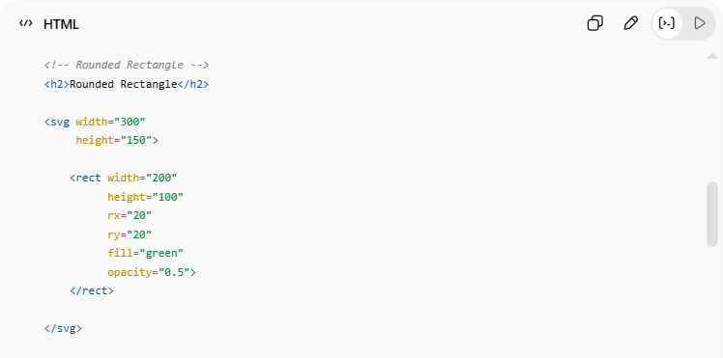
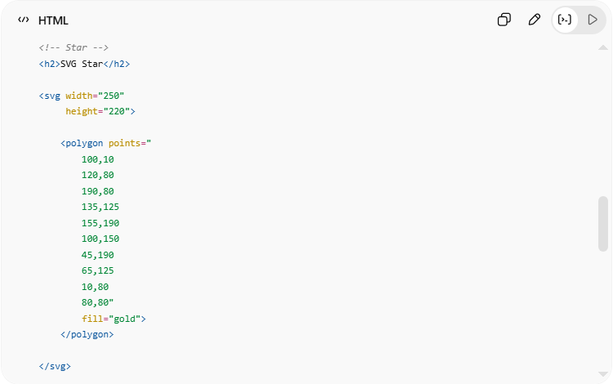
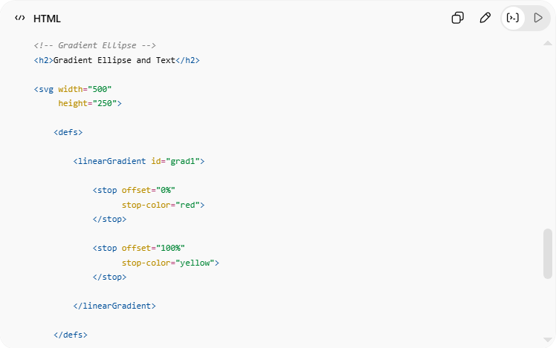
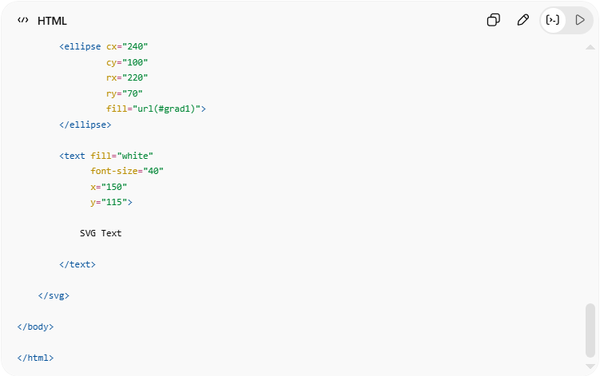
<!DOCTYPE html>
<html>
<head>
<title>HTML SVG Graphics</title>
</head>
<body>
<h1>HTML SVG Graphics</h1>
<!-- Circle -->
<h2>SVG Circle</h2>
<svg width="200"
height="200">
<circle cx="100"
cy="100"
r="50"
fill="red">
</circle>
</svg>
<!-- Rectangle -->
<h2>SVG Rectangle</h2>
<svg width="300"
height="150">
<rect width="200"
height="100"
fill="blue">
</rect>
</svg>
<!-- Rounded Rectangle -->
<h2>Rounded Rectangle</h2>
<svg width="300"
height="150">
<rect width="200"
height="100"
rx="20"
ry="20"
fill="green"
opacity="0.5">
</rect>
</svg>
<!-- Star -->
<h2>SVG Star</h2>
<svg width="250"
height="220">
<polygon points="
100,10
120,80
190,80
135,125
155,190
100,150
45,190
65,125
10,80
80,80"
fill="gold">
</polygon>
</svg>
<!-- Gradient Ellipse -->
<h2>Gradient Ellipse and Text</h2>
<svg width="500"
height="250">
<defs>
<linearGradient id="grad1">
<stop offset="0%"
stop-color="red">
</stop>
<stop offset="100%"
stop-color="yellow">
</stop>
</linearGradient>
</defs>
<ellipse cx="240"
cy="100"
rx="220"
ry="70"
fill="url(#grad1)">
</ellipse>
<text fill="white"
font-size="40"
x="150"
y="115">
SVG Text
</text>
</svg>
</body>
</html>

Real Example
# Source: ScreenShot Source: Provided by: [Persons Table -> ID Column: 1, Name_En Column: Motasem Essam] -> Tool: [Automation Table -> ID Column: 16, Name_En Column: Screen Capture] -> From [Operating System: Windows] on [5/6/2026]

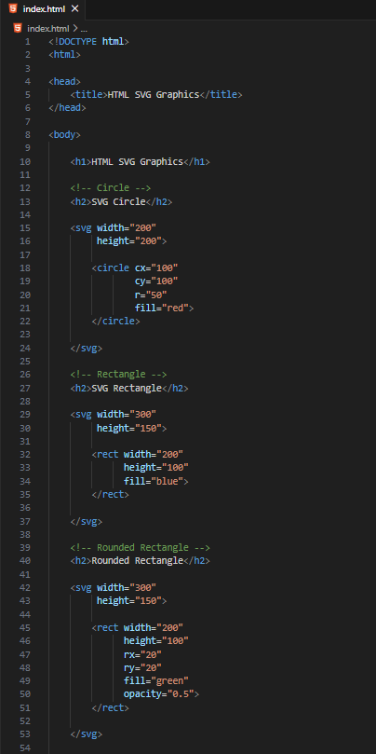
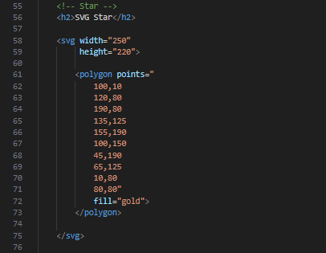
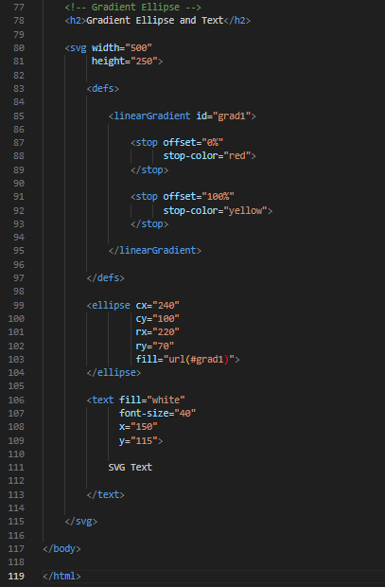
<!DOCTYPE html>
<html>

<head>
<title>HTML SVG Graphics</title>
</head>

<body>

<h1>HTML SVG Graphics</h1>

<!-- Circle -->
<h2>SVG Circle</h2>

<svg width="200"
height="200">

<circle cx="100"
cy="100"
r="50"
fill="red">
</circle>

</svg>

<!-- Rectangle -->
<h2>SVG Rectangle</h2>

<svg width="300"
height="150">

<rect width="200"
height="100"
fill="blue">
</rect>

</svg>

<!-- Rounded Rectangle -->
<h2>Rounded Rectangle</h2>

<svg width="300"
height="150">

<rect width="200"
height="100"
rx="20"
ry="20"
fill="green"
opacity="0.5">
</rect>

</svg>

<!-- Star -->
<h2>SVG Star</h2>

<svg width="250"
height="220">

<polygon points="
100,10
120,80
190,80
135,125
155,190
100,150
45,190
65,125
10,80
80,80"
fill="gold">
</polygon>

</svg>

<!-- Gradient Ellipse -->
<h2>Gradient Ellipse and Text</h2>

<svg width="500"
height="250">

<defs>

<linearGradient id="grad1">

<stop offset="0%"
stop-color="red">
</stop>

<stop offset="100%"
stop-color="yellow">
</stop>

</linearGradient>

</defs>

<ellipse cx="240"
cy="100"
rx="220"
ry="70"
fill="url(#grad1)">
</ellipse>

<text fill="white"
font-size="40"
x="150"
y="115">

SVG Text

</text>

</svg>

</body>

</html>
# Source: GIF Source: Provided by: [Persons Table -> ID Column: 1, Name_En Column: Motasem Essam] -> Tool: [Automation Table -> ID Column: 17, Name_En Column: GIF Recorder] -> From [Operating System: Windows] on [5/6/2026]


🧪 What You Can Test
# Source: AI Source: Provided by: [Data Path: Persons Table -> ID Column: 1, Name_En Column: Motasem Essam] -> From: [ChatGPT] on [5/6/2026]
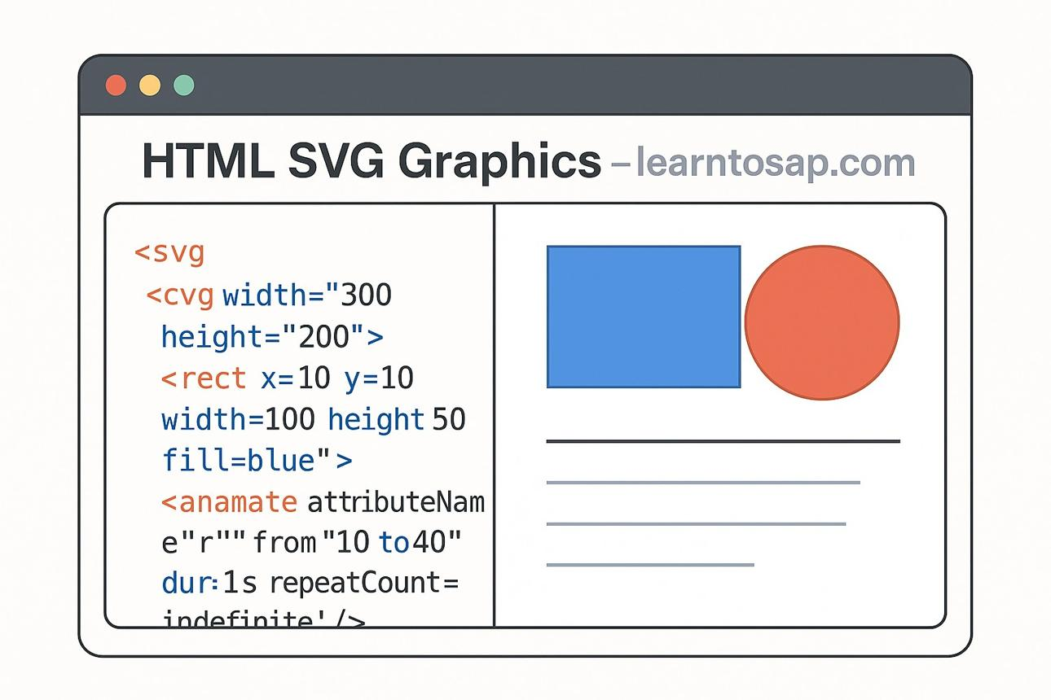
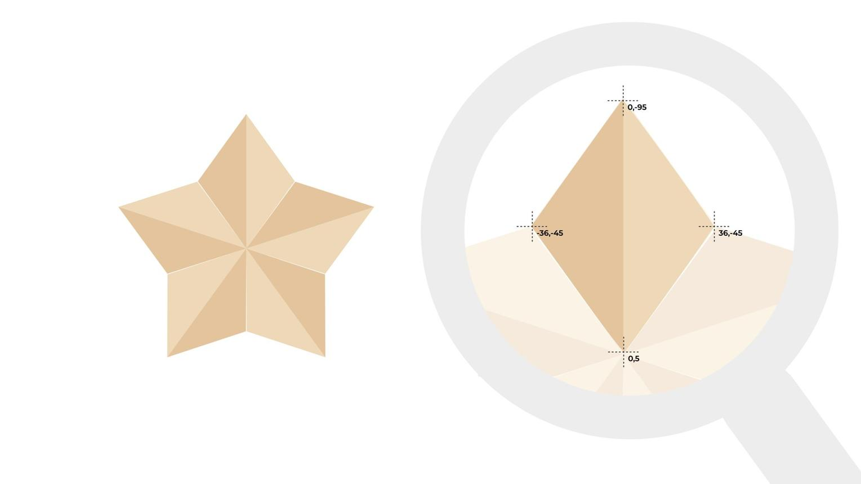
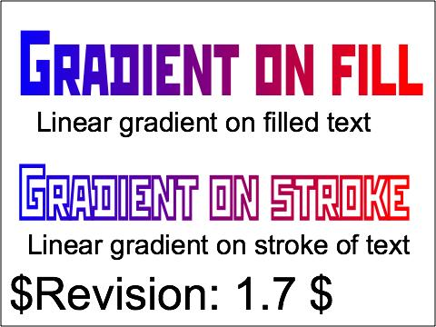
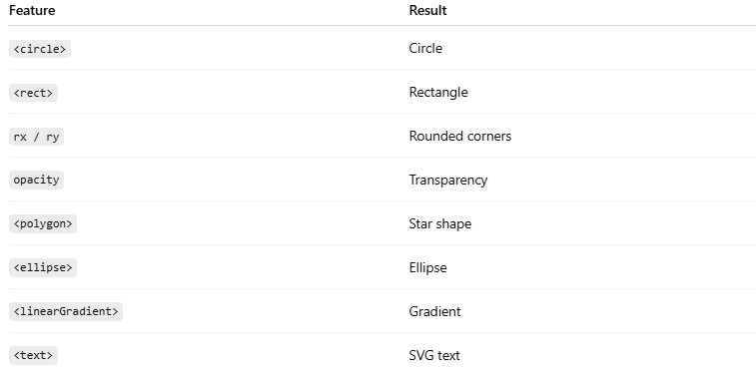
Feature | Result
<circle> | Circle
<rect> | Rectangle
rx / ry | Rounded corners
opacity | Transparency
<polygon> | Star shape
<ellipse> | Ellipse
<linearGradient> | Gradient
<text> | SVG text

⚠️ Important Notes

✅ SVG is vector-based
# Source: AI Source: Provided by: [Data Path: Persons Table -> ID Column: 1, Name_En Column: Motasem Essam] -> From: [ChatGPT] on [5/6/2026]
👉 No quality loss when scaling

✅ SVG works well for logos/icons
# Source: AI Source: Provided by: [Data Path: Persons Table -> ID Column: 1, Name_En Column: Motasem Essam] -> From: [ChatGPT] on [5/6/2026]
👉 Sharp graphics at all sizes

✅ SVG elements can be styled with CSS
# Source: AI Source: Provided by: [Data Path: Persons Table -> ID Column: 1, Name_En Column: Motasem Essam] -> From: [ChatGPT] on [5/6/2026]
👉 Easy customization

❌ Complex SVG graphics may affect performance
# Source: AI Source: Provided by: [Data Path: Persons Table -> ID Column: 1, Name_En Column: Motasem Essam] -> From: [ChatGPT] on [5/6/2026]
👉 Especially large animations

🚀 In short:
# Source: AI Source: Provided by: [Data Path: Persons Table -> ID Column: 1, Name_En Column: Motasem Essam] -> From: [ChatGPT] on [5/6/2026]
HTML SVG creates scalable vector graphics like circles, rectangles, stars, gradients, ellipses, and text directly inside webpages.

⚠️ Important Notes

✅ Use Canvas for dynamic graphics
# Source: AI Source: Provided by: [Data Path: Persons Table -> ID Column: 1, Name_En Column: Motasem Essam] -> From: [ChatGPT] on [5/6/2026]
👉 Games, animations, charts

✅ Use SVG for scalable shapes
# Source: AI Source: Provided by: [Data Path: Persons Table -> ID Column: 1, Name_En Column: Motasem Essam] -> From: [ChatGPT] on [5/6/2026]
👉 Logos, icons, diagrams

❌ Canvas is NOT accessible without JS
# Source: AI Source: Provided by: [Data Path: Persons Table -> ID Column: 1, Name_En Column: Motasem Essam] -> From: [ChatGPT] on [5/6/2026]
👉 SVG is better for accessibility

🚀 In short:
# Source: AI Source: Provided by: [Data Path: Persons Table -> ID Column: 1, Name_En Column: Motasem Essam] -> From: [ChatGPT] on [5/6/2026]
HTML graphics use <canvas> for JavaScript-based drawing and <svg> for scalable vector graphics.

